## Week 1 – Introduction to Causal Effects

### Practice Quiz 1

1. Which of the following represents what the average outcome would have been had no one been treated?
$E(Y^{0})$

2. We can only observe one potential outcome for each subject is:
   1. The fundamental problem of causal inference.

### Practice Quiz 2

1. Which assumption is also refereed to as the ‘no unmeasured confounders’ assumption?
   1. Ignorability.
2. Which causal assumption requires that there is no interference between units?
   1. SUTVA

### Causal Effects

1. The fundamental problem of causal inference is that:
   1. We can only observe one potential outcome for each subject.
2. Which of the following represents the causal effect of treatment on the treated?
$E\left(Y^{1}|A=1\right)-E(Y^{0}|A=0)$

3. Which of the following represents the average causal effect for the population?
$E\left(Y^{1}\right)-E(Y^{0})$

4. Which assumption would be violated if the effectiveness of treatment on an individual depended on the treatment status of other individuals?
   1. SUTVA.
5. Which assumption would be violated if we were interested in the causal effect of treatment for people aged 40-80 but *everyone* over age 70 received the treatment?
   1. Positivity.
6. If the consistency assumption holds, then the observed outcome for a treated subject is equal to their potential outcome under that treatment.
   1. True.
7. Which of the following can most easily be thought of as an intervention?
   1. Changing medication.
8. Treatment assignment being ignorable given confounders X means:
   1. Within levels of X, treatment assignment is independent from the potential outcomes.
9. Computing means within levels of covariates and then combining these estimates is known as:
   1. Standardisation.

## Week 2 – Confounding and DAGs

### Practice Quiz

1. What type of path is this?



* 1. Fork.

1. What type of path is this?



* 1. Chain.

1. This DAG is consistent with which factorisation of the joint distribution $P(A,B,C,D)$?

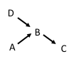

$P\left(D\right)P\left(A\right)P\left(B | A,D\right)P(C|B)$

1. Is there a collider on the path from A to C?



* 1. No.

### Identify from DAGs Sufficient Sets of Confounders

1. 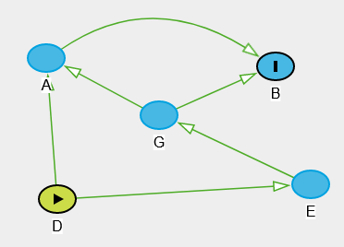 How many paths are there from D to B?
   1. 4 ($D→A→B, D→A←G→B, D→E→G→B, D→A←G→B)$
2. 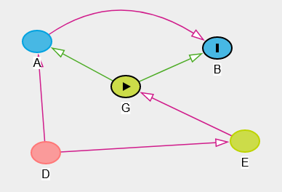How many back-door paths are there from G to B?
   1. 1 $(G←E← D→A→B)$
3. Is G independent from D given E?
   1. Yes.
4. Is D independent from G?
   1. No.
5. How many parents does B have?
   1. 2 (A and G).
6. 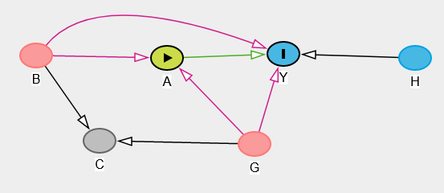 Assuming we’re interested in the causal effect of A on Y, how many backdoor paths are there?
   1. 4 $(A←G→Y, A←B→Y, A←G→C←B→Y, A←B→C←G→Y)$.
7. How many unblocked back-door paths are there from A to Y?
   1. 2 ( $A←G→C←B→Y$ is blocked).
8. Conditioning on C creates a link between which two nodes?
   1. B and G.
9. Does conditioning on $\{G,B\}$ satisfy the back-door path criterion?
   1. Yes.
10. The set of variables to control for based on the disjunctive cause criterion is:
$\{B,G,H\}$

11. Does the set $\{C,B\}$ satisfy the back-door path criterion?
    1. No.

## Week 3 – Matching and Propensity Scores

### Practice Quiz 1

1. Balance refers to:
   1. The distribution of confounders being similar for treated and untreated subjects.
2. In matching, ‘distance’ is a measure of:
   1. How similar the values of confounders are for different people.
3. A good match is one where:
   1. The distance is small.

### Practice Quiz 2

1. For optimal matching, what is optimised?
   1. The total distance is minimised.
2. After matching, balance can be assessed by:
   1. Standardised differences.
3. A large standardised difference for a covariate suggests:
   1. There is imbalance on this covariate.
4. If there is a large treatment effect, then we expect the observed difference in the mean of the outcome between matched pairs to be:
   1. Very different from the difference in means if we randomly permute the treatment labels.

### Matching

1. Matching and calculation of standardised differences on the matched data can take place without using the outcome variable.
   1. True.
2. Optimal matching is less computationally demanding than greedy matching.
   1. False.
3. A smaller value of the caliper would tend to lead to:
   1. Smaller standardised differences.
4. Many-to-one matching, as opposed to pair matching, would tend to lead to estimates of causal effects that have:
   1. More bias but less variability.
5. A method for assessing the impact of violations of causal assumptions is:
   1. Sensitivity analysis.
6. Standardised differences are very sensitive to sample size.
   1. False.

### Propensity Score Matching

1. The propensity score is:
   1. The probability of treatment given covariates.
2. Trimming the tails involves:
   1. Excluding subjects with extreme values of the propensity score.
3. If the propensity score if exactly equal to 0 or 1 for some subjects, which causal assumption is violated?
   1. Positivity assumption.
4. Propensity score matching involves in the following steps (in order):
   1. Estimate propensity scores.
   2. Check propensity score overlap.
   3. Match on propensity score.
   4. Check covariate balance.
5. If we use a caliper on the propensity score of 0.1, then:
   1. Matches will never differ in the propensity score by more than 0.1.

## Week 4 – Inverse Probability of Treatment Weighting (IPTW)

### Practice Quiz

1. Someone who was likely to be treated given their covariates, but wasn’t:
   1. Will have a large weight.
2. Marginal structural models are models of:
   1. The mean of the potential outcome as a function of possible values of treatment.
3. IPTW estimation works because:
   1. It creates an unconfounded pseudo-population.

### IPTW

1. IPTW involves weighting the data by:
   1. 1 divided by the propensity score for treated subjects
   2. 1 divided by 1 minus the propensity score for controls.
2. Among control subjects, would someone with a high value of the propensity score get a higher or lower weight than someone with a low value of the propensity score?
   1. Higher weight.
3. Marginal structural models are used to model:
   1. Average causal effects.
4. The pseudo-population refers to the population:
   1. After weighting.
5. Compared with situations where weights are small, large weights lead to causal effect estimates that are:
   1. More variable.
6. Near violation of the positivity assumption occurs when there are some weights that are very large.
   1. True.
7. Weight truncation is the same as trimming the tails.
   1. False.
8. Weight truncation, compared with no weight truncation, will likely lead to causal effect estimates:
   1. That are more biased, but have less variance.
9. Doubly robust estimators require that:
   1. Either the propensity score model or outcome model are correctly specified.

## Week 5 – Instrumental Variables Methods

### Practice Quiz 1

1. An instrumental variable is a variable that:
   1. Affects treatment and only affects the outcome through its effect on treatment.
2. The potential treatment value of an always-taker is:
   1. $A^{0}=1$, $A^{1}=1$
3. The monotonicity assumption applies that there is no:
   1. Defiers.

### Practice Quiz 2

1. The second stage of two-stage least squares is:
   1. Regression of the outcome on the predicted value of treatment (from the stage 1 model).
2. A strong instrument is one that:
   1. Is highly predictive of treatment.

### IVs/Causal Effects in Randomised Trials with Non-Compliance

1. The intention-to-treat effect is:
   1. The causal effect of treatment assignment on the outcome.
2. The potential treatment value of a complier is:
$A^{0}=0, A^{1}=1$

3. Treatment assignment has no impact on treatment received for:
   1. Always takers and never takers.
4. In instrumental variable analysis, what is meant by a *local* treatment effect?
   1. Treatment effect among compliers only.
5. The monotonicity assumption is necessary for estimation of:
   1. CACE.
6. If we don’t make the monotonicity assumption, someone who was observed to have Z = 1 and A = 0 is:
   1. Either a never taker or defier.
7. If we do make the monotonicity assumption, someone who was observed to have Z = 1 and A = 0 is:
   1. Definitely a never taker.
8. The assumption that the instrumental variable, Z, only affects the outcome through its affect on treatment is called:
   1. The exclusion restriction.
9. The first stage of two-stage least squares is:
   1. Regression of treatment received on the instrumental variable.
10. The strength of an instrumental variable can be measured by:
    1. The association between the IV and treatment.
11. A weak instrument will tend to lead to estimates of causal effects that have:
    1. Large standard errors.
12. Instrumental variable methods do not require:
    1. The ignorability assumption.